**Moderate to Severe Evaluation**

Sample_id : **6PW9WR(Cat)**

Link:<https://release.animalbiome.com/pet/assessment/report/summary/4ecb86e1-b346-4ba9-a738-518e56d18f7d>

Cats and dogs:

Any two of the following:

(

High Red Flag Megamonas OR (failed)

High Red Flag Sutterella OR (**passed**)

High Red Flag Collinsella OR (failed)

Low Red Flag Bacteroides OR (**passed**)

Low Red Flag Blautia (**passed**)

);

OR

Cats:

11 or more yellow flags;(**Passed**)

OR 9 or more red flags;(failed)

High Red Megamonas,High red collinsella failed.



Low group evaluation:

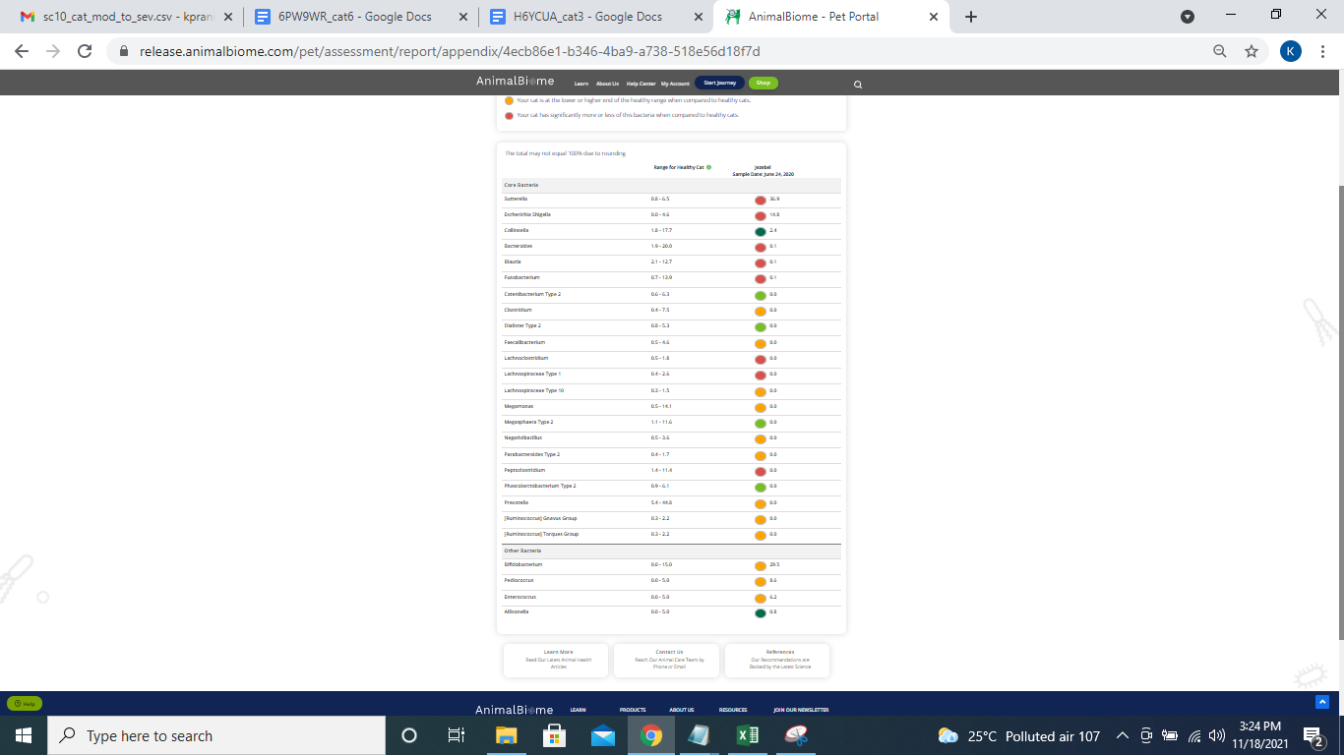

low red blautia : passed.

Low red bacteroides : passed (3 conditions satisfied ) in the primary group.

Total yellow flags : 12

Red flags : 8

The result : **True True False**

Moderate to severe results:Pass

Expected result : **Moderate to severe**

Achieved result : **passed.**

